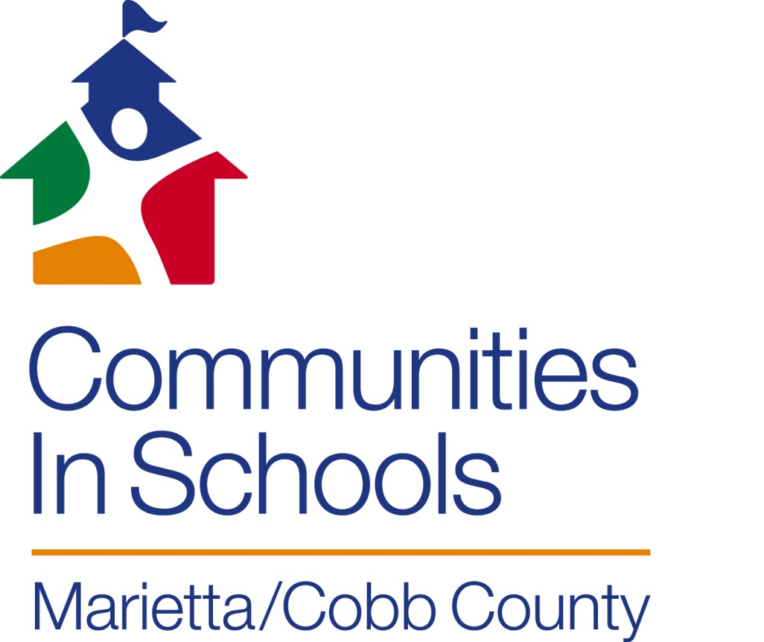

**Sponsorship Packet**

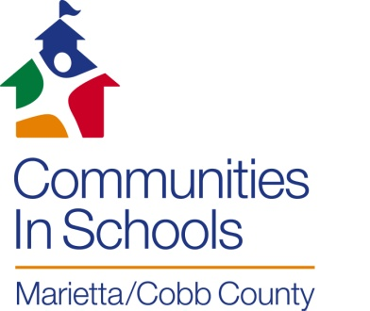

For nearly 15 years, Communities In Schools (CIS) of Marietta/Cobb County has been helping our students achieve in school, graduate from high school, and go on to bright futures.

CIS is the nation’s leading and most effective dropout prevention organization, and the only one proven to both decrease dropout rates and increase graduation rates. Our mission is straightforward – to *surround students with a community of support, empowering them to stay in school and achieve in life.* The vision of CIS of Marietta/Cobb County (CISMCC) is that through a powerful, collaborate community effort, families will be provided with the necessary resources, inspiration and motivation for all students to obtain a high school diploma.

CIS of Marietta/Cobb County (CISMCC) is part of the CIS of Georgia network of programs serving local communities across the state. We are passionate and committed professionals working in our public schools in partnership with administrators, teachers, and the community. We provide students with a one-on-one relationship with a caring adult, a safe place to learn and grow, a healthy start and future, a marketable skill upon graduation and a chance to give back to peers and the community.

**Outcomes for Our Students and Community**

Georgia has an average of 120 students dropping out of school each day, among the nation’s highest. Dropouts negatively impact the economy, costing our communities millions of dollars in forgone revenue and sadly, lost opportunities for young men and women to contribute productively to our communities.

CIS uses an integrated student support model which places trained site coordinators in the schools to help students succeed, graduate and prepare for college or career. This support model addresses student and family needs both inside and outside the classroom by connecting critical community resources. The 2013-2014 outcomes for CIS of Marietta/Cobb County prove this:

* 8,168 total, individual students received CIS services last year; 884 received sustained, case-managed services
* 96% of students working with CISMCC graduated or stayed in school
* 690 community volunteers donated 5,364 hours, $109,328 in value
* 1,392 parents received services, engagement and support from CISMCC



*“Communities In Schools of Marietta/Cobb County is lucky to be in a county with many resources, both people and financial. We have volunteer opportunities for community involvement and two great schools systems. Yet we have a large population of families and children who need our help in order for the students to succeed in school. By bringing resources to the schools through the CIS Model to meet the needs of the children and remove barriers to success, we change the future for our children and their families. Seeing hope in their eyes and smiles on their faces when they get that high school diploma with plans for the future is the greatest experience an individual can have. CIS of Marietta/Cobb County looks forward to the day when every child in Cobb County is on the road to success in life starting with their high school diploma. Let us know what you are willing to do to make this possible for all of our children.”*

Carol Fey, Executive Director, CIS of Marietta/Cobb County 

**Corporate Sponsorship Opportunities 2015**

It is through Sponsor support of CISMCC that we are able to fulfill our mission of supporting student achievement in school and in life. In turn, Sponsors of our organization garner exposure at three of our highly visible and successful events and at other events throughout the year:

These events include:

“**Students Growing Tomorrow’s Communities**” – annual luncheon which provides students with the opportunity to network with business leaders in the community, hear a motivational speaker and enjoy a celebration of their pending graduation.

**Schoolhouse Rock n’ Run 5k – the inaugural race** will be held in downtown Atlanta in October 2015 as we invite supporters from across the metro area to support us.

**Bowl-a-Thon** which brings together volunteers, corporate teams, employees and other stakeholders in a fun-filled morning to “strike out drop-outs”.

**Platinum Sponsor $10,000**

* Company logo on all marketing materials
* Recognition on CIS social media, website, press releases
* 6 invitations to attend Student Success Luncheon
* Logo displayed on all tables at Students Growing Tomorrow’s Communities Luncheon
* Opening remarks by company representative at Students Growing Tomorrow’s Communities Luncheon
* 1 free team (4 bowlers) at Bowl-A-Thon
* 6 Schoolhouse Rock n’ Run 5k Race entries
* Business name and/or logo on Schoolhouse Rock n’ Run 5K race refreshment tables
* Company logo on Run T-shirts

**Gold Sponsor $5,000**

* Company logo on all marketing materials
* Recognition on CIS social media, website, press releases
* 4 invitations to attend Students Growing Tomorrow’s Communities Luncheon
* Logo displayed on prominent sponsor board at Students Growing Tomorrow's Communities Luncheon
* 1 free team (4 bowlers) at Bowl-A-Thon
* 4 Schoolhouse Rock n’ Run 5k race entries
* Company logo on Run T-shirts

**Silver Sponsor $2,500**

* Company logo on all marketing materials
* Recognition on CIS social media, website, press releases
* 2 invitations to attend Students Growing Tomorrow’s Communities Luncheon
* Logo displayed on prominent sponsor board at Students Growing Tomorrow's Communities Luncheon
* 1 free team (4 bowlers) at Bowl-A-Thon
* 2 Schoolhouse Rock n’ Run 5k race entry

**Bronze Sponsor $1,000**

* Company logo on all marketing materials
* Recognition on CIS social media, website, press releases
* 1 invitation to attend Students Growing Tomorrow’s Communities Luncheon

**Friend of Communities In Schools $500**

* Company logo on all marketing materials
* Recognition on CIS social media, website, press releases

**Reality University (Reality U) Corporate Volunteer Opportunities**

*Reality U is a one-day financial literacy event designed to help students understand some of the “realities” involved in preparing for an employable future and adulthood. At Reality U, students are provided an adult scenario of their chosen career, complete with marital status, number of children, occupation, and net monthly income. Students visit a variety of booths to “purchase” housing, transportation, communication services, child care, food, utilities, insurance, etc. Volunteers are needed to run each booth. No experience or special skills necessary. A brief training provided at the event and then the fun begins!*

* Chance for co-workers to become better acquainted with each other in a fun environment while doing good work in the community
* Opportunity for team building
* Teach financial literacy to Cobb County youth
* Opportunity to increase value of employee’s volunteer time with a matching gift of a financial donation
* Afterwards, we will take a group photo with a poster showing how many youth were served during your session

**Volunteer Opportunities for Working Professionals**

**Job Shadowing:**

Provide an opportunity for small groups of high school students to experience an occupational work setting for a few hours during a week day. CISMCC would like to secure job sites representing various occupations for students to become more acquainted with a particular career setting of interest to them.

**Mentors:**

Work one-on-one with a high school student as an adult role model helping with post-secondary planning and the skills needed to be successful beyond graduation. Mentoring is done during the weekday on site at our school sites for about an hour per week.

**Speakers:**

Speakers are needed monthly for the Ambassador Leadership Development Program. Our PLC student ambassadors have committed to a year-long program designed to increase self-efficacy to succeed in school and in life. All PLC students can benefit from the guidance of working professionals. Speakers are needed to address topics such as time management, interview skills, resume writing, dressing for success in the business world, communication, lifelong learning, service, or ANY topic of interest that can benefit our students!

**For more information regarding volunteer opportunities, please contact Patty Yohn, Office Manager/Volunteer Coordinator: 678-503-0901, pyohn@cismcc**

**Sponsorship Commitment Form**

Contact Information

Company Name:­­­­­­­­­­­­­­­­­­­­­­_______________________________________________________________________

Primary Contact/Title:___________________________________________________________________

Email:__________________________________________ Phone:________________________________

Address:______________________________________________________________________________

City:____________________________________________ State:_____________ Zip:________________

Please indicate level of sponsorship:

­­­­­­­­­­­­­­­­­­­_____________________________________________________________________________________

**(Volunteer Opportunities: please contact Patty Yohn, Office Manager/Volunteer Coordinator, 678-503-0901,** [**pyohn@cismcc.org**](mailto:pyohn@cismcc.org)**)**

**Note: Logo Requirements**

* Logos can be PNG, PDF, or JPG
* Black & white, or 2-4 color
* Any size logo is acceptable

Please submit form and questions to:

Carol Fey

[cfey@cismcc.org](mailto:cfey@cismcc.org)

678-503-0901

316 Alexander Street, Suite 5

Marietta, Georgia 30060